**Lesson 5 Demo 1**

**Pull Requests**



Steps to be followed:

* Create a branch
* Create a pull request

**Step 1: Create a branch**

* 1. Below is the GitHub account with a repository created:

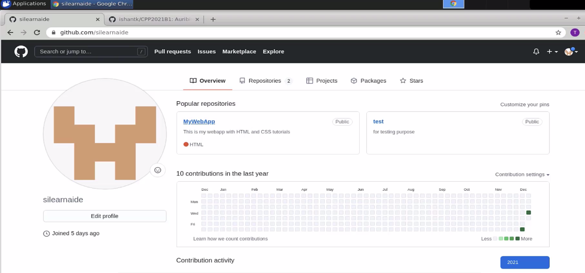

* 1. There is a branch created called *feature 1.*

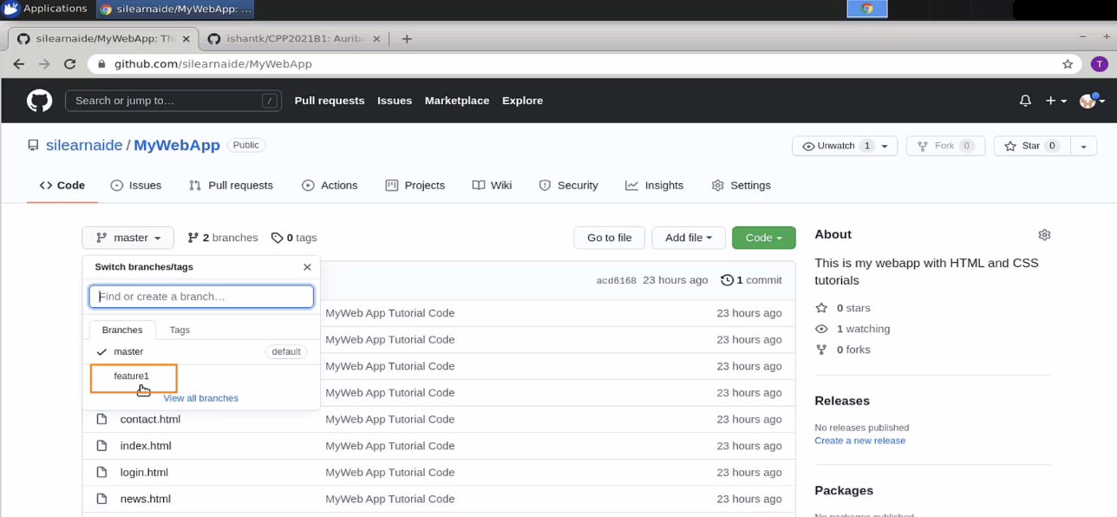

* 1. Now in the same repository, go to the MyWebApp directory, as below:

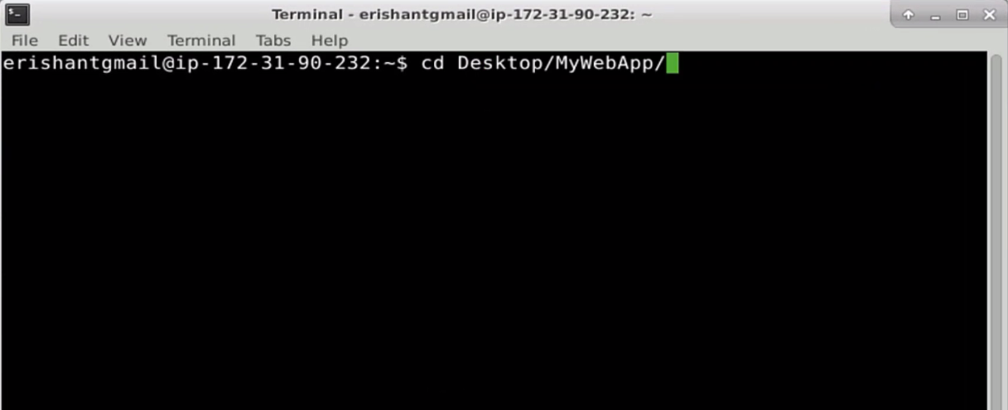

* 1. Type **git branch**

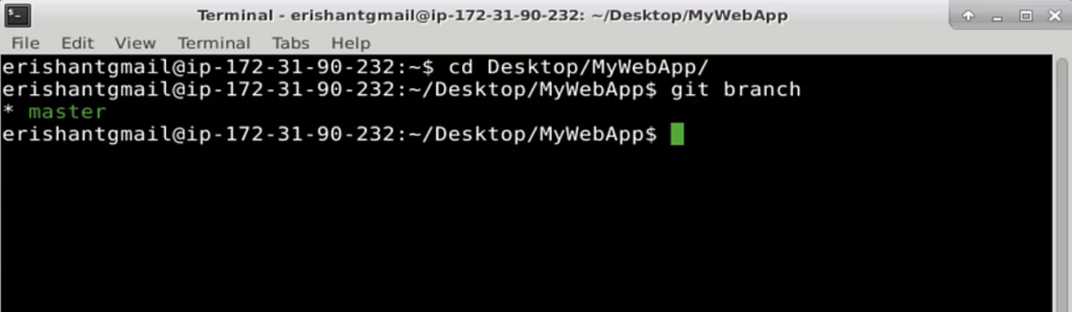

* 1. Type **git checkout –b myfeature**

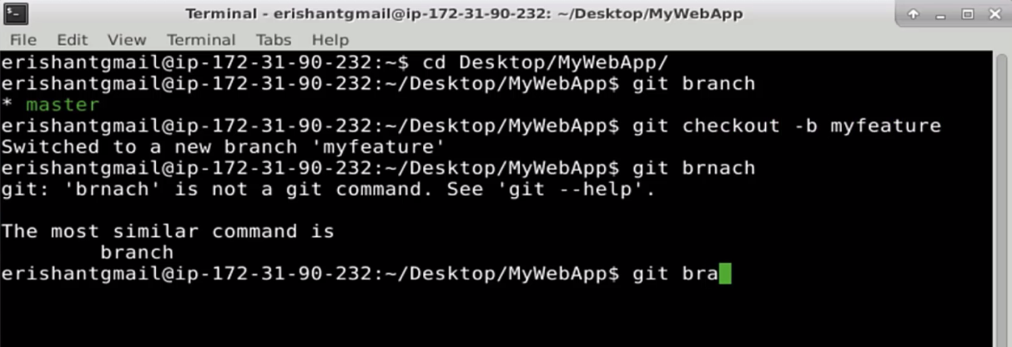

* 1. This has resulted in the creation of a new branch called myfeature.

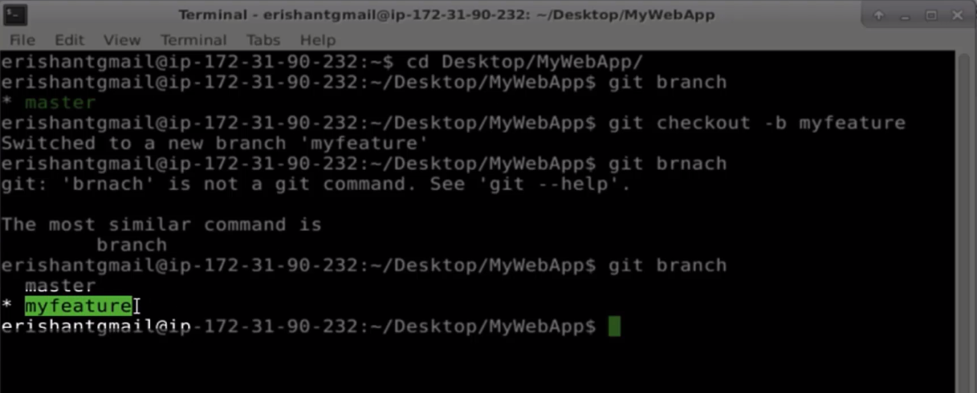

**Step 2: Create a pull request**

* 1. Create one html page using the touch command

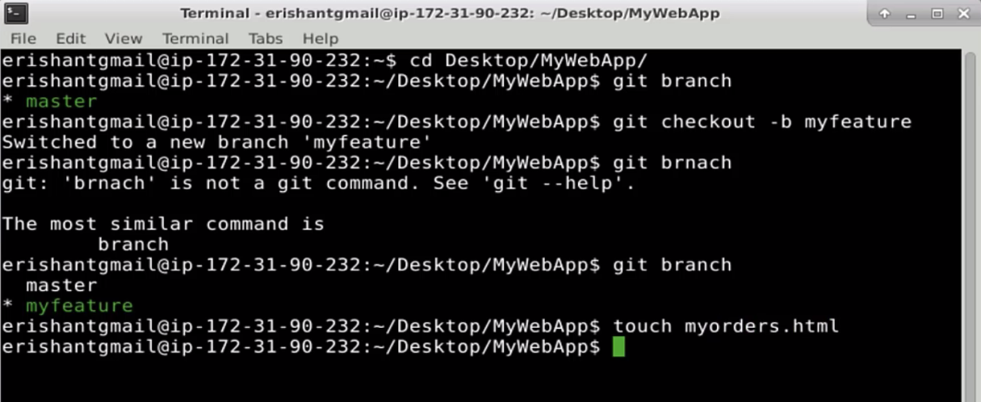

* 1. Now, add this file and commit it, with a message for the changes done.

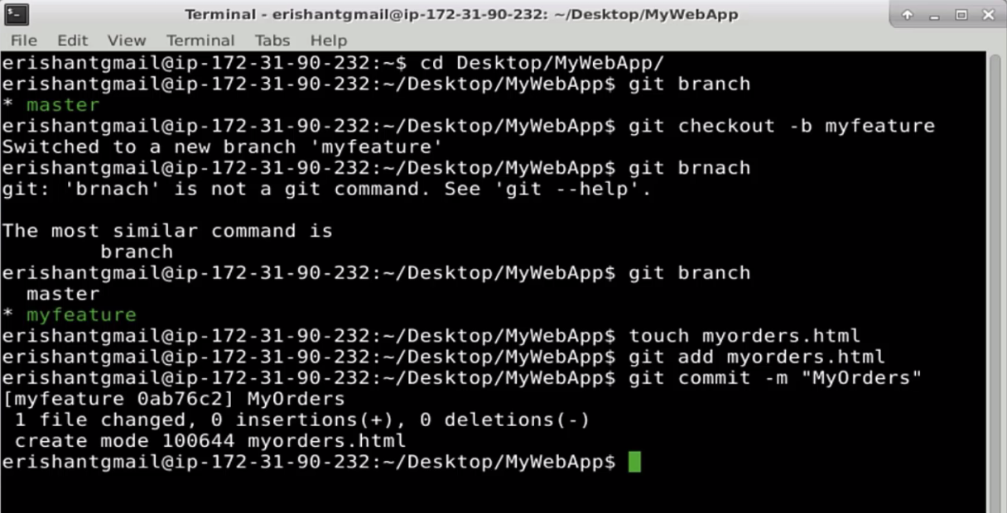

* 1. Push the code, using the git push command to the myfeature branch

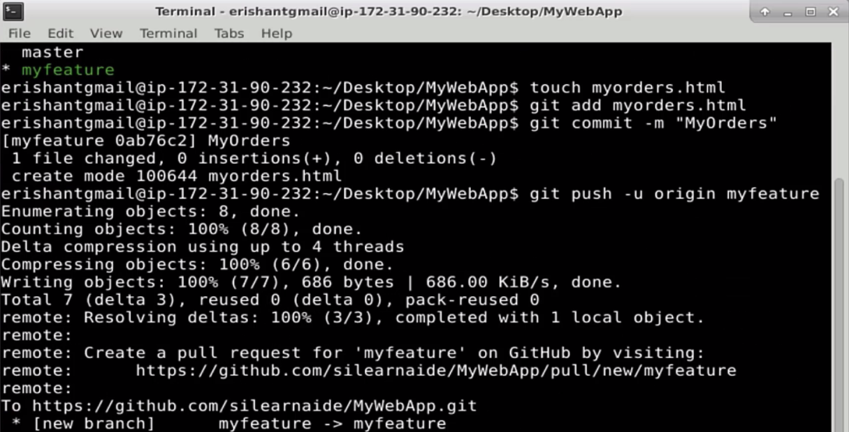

* 1. You are not collaborating with anyone, but you can see one notification has come up in the repository. You can see a *compare & pull request* option.

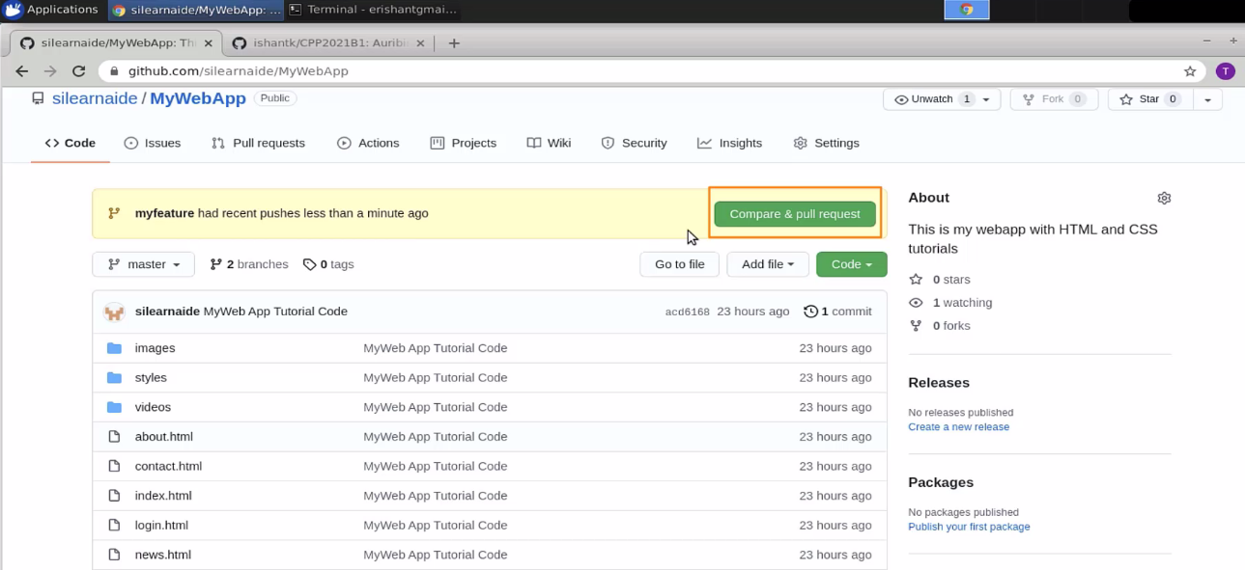

* 1. Go to the **pull requests** section

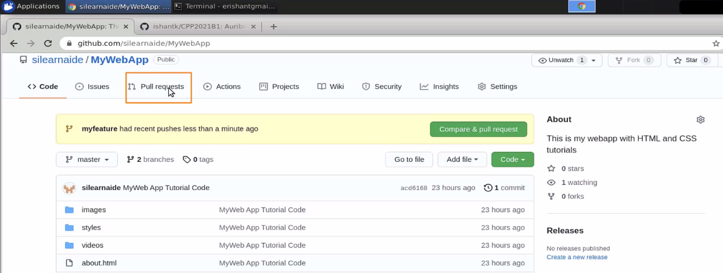

* 1. You can see a branch “myfeature” which has some push.

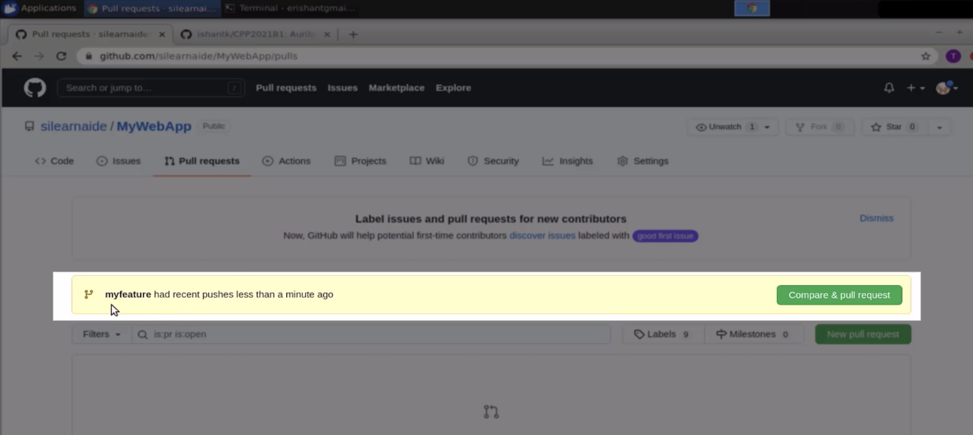

* 1. Click on the **Compare & pull request** button

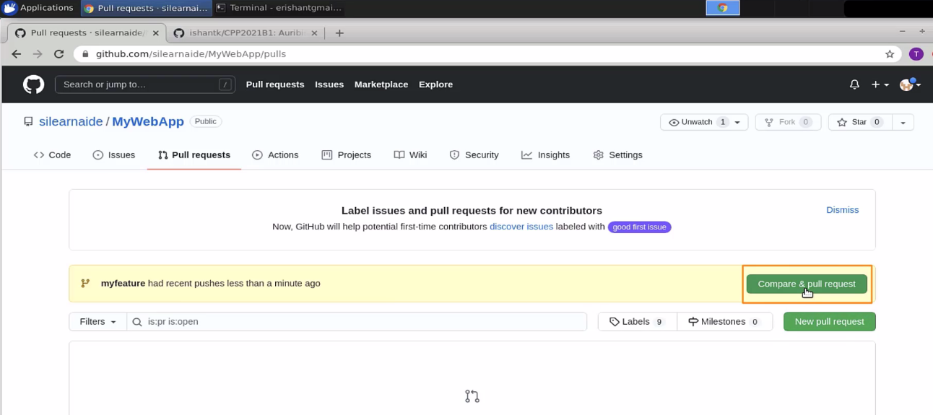

* 1. Compare and create a pull request

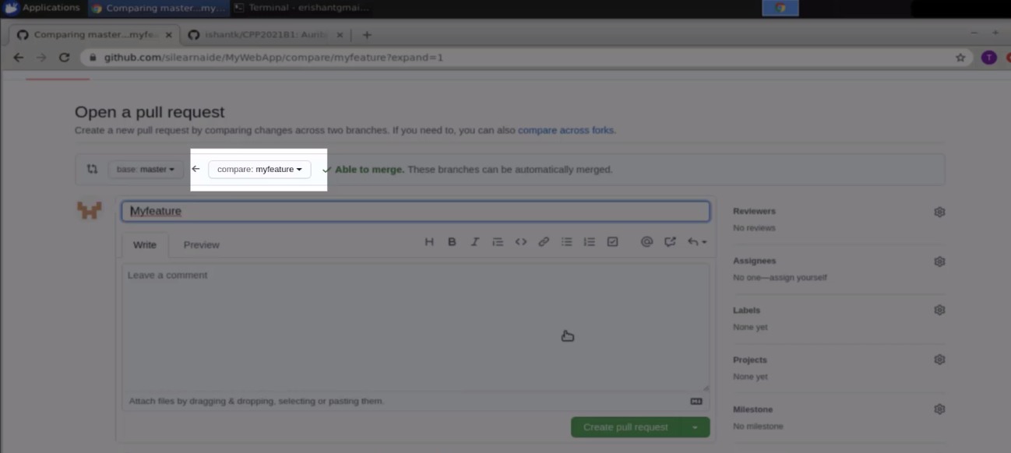

* 1. You can either create a draft of the pull request or create a pull request.

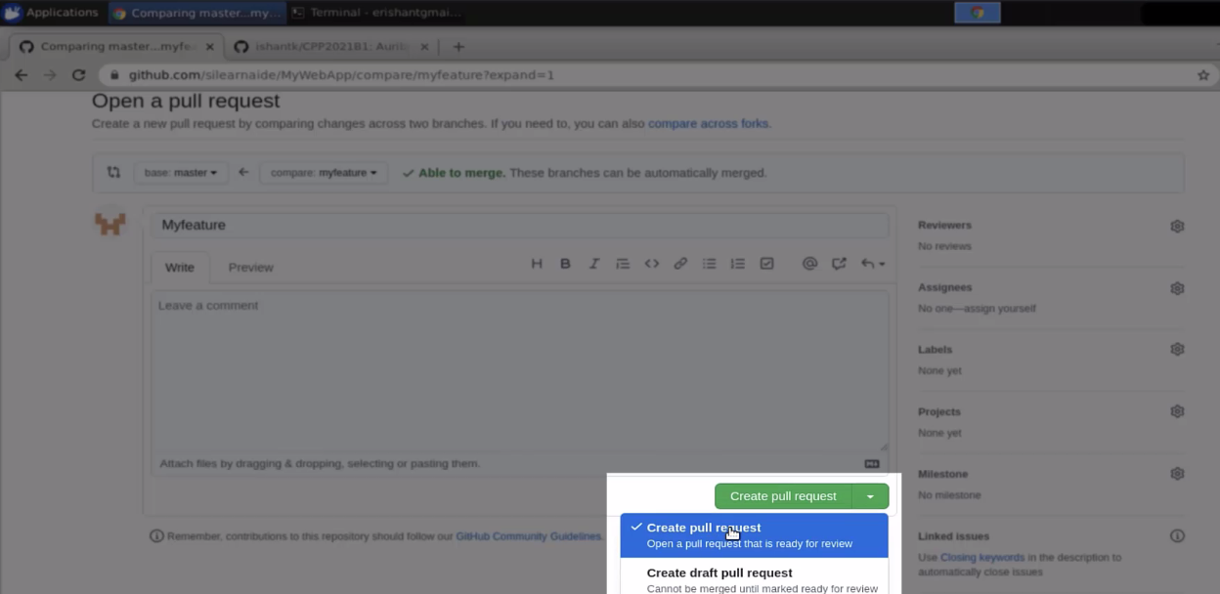

* 1. Click on the **Create pull request** button

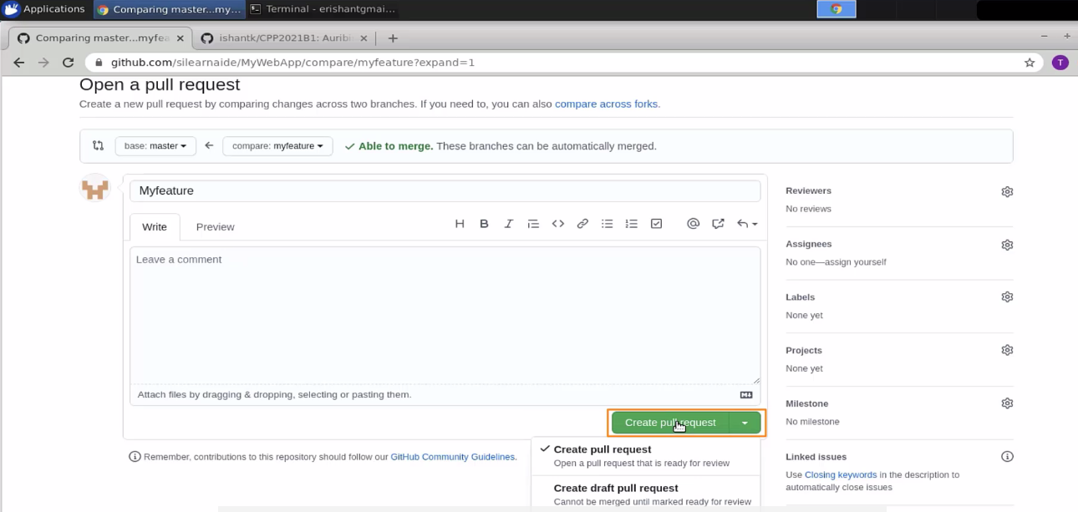

* 1. You will get an option to create a merge pull request.

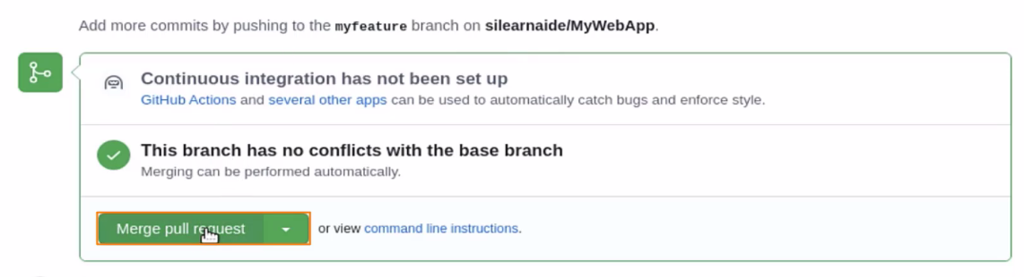

* 1. Click on the **confirm merge** button

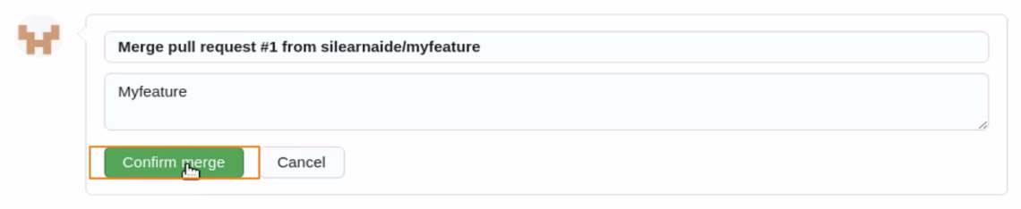

* 1. The feature will now be added to the repository.

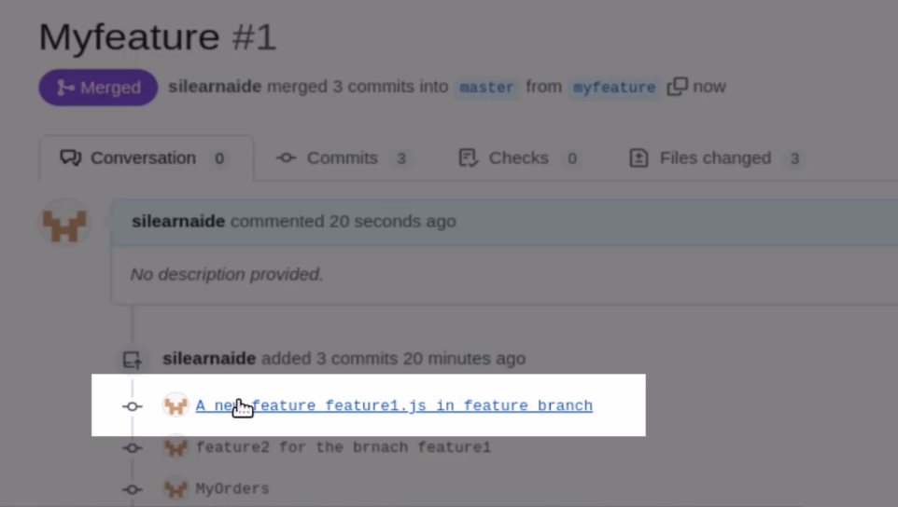

* 1. These pull requests generally come from the team members collaborating on multiple features. Open another repository as shown below:

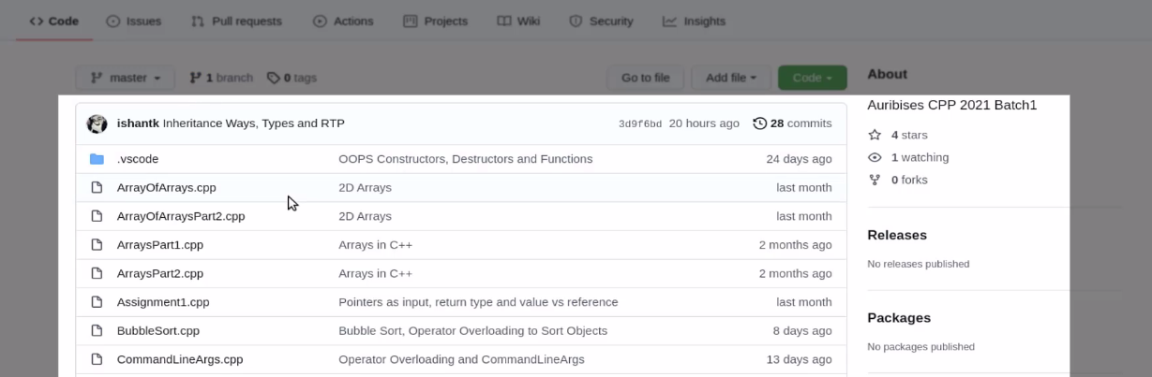

* 1. You can see an option **forks.**

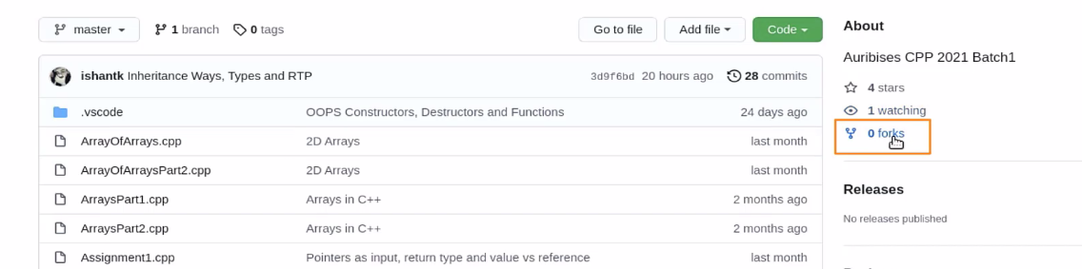

* 1. Click on the **fork** button on the top right side

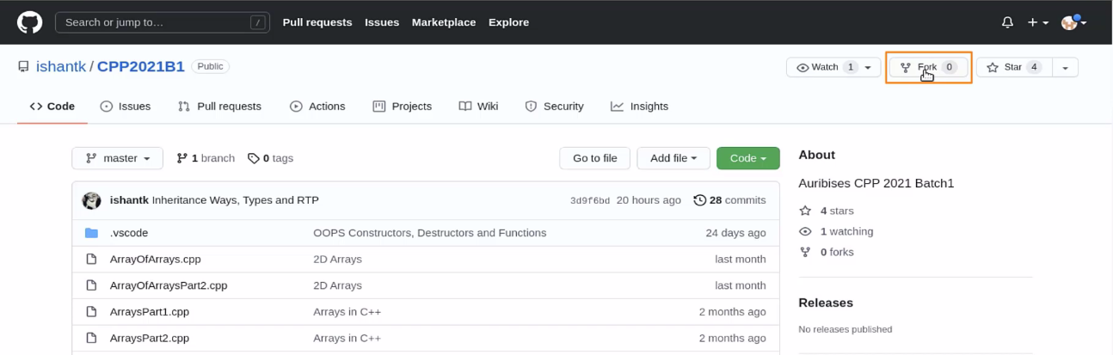

* 1. As soon as you click on the fork button, you can see a new repository created.

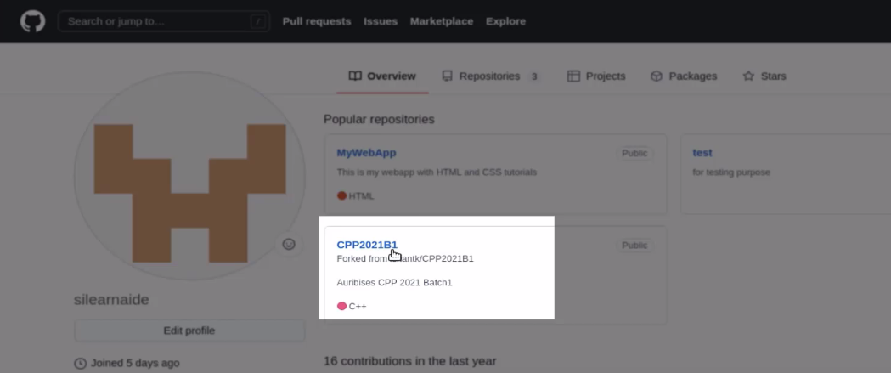

* 1. You can now work in this repository. Now, let us clone this repository. Copy the link shown:

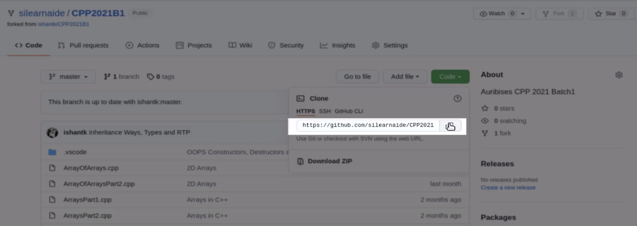

* 1. Go to the downloads directory and clone the repository

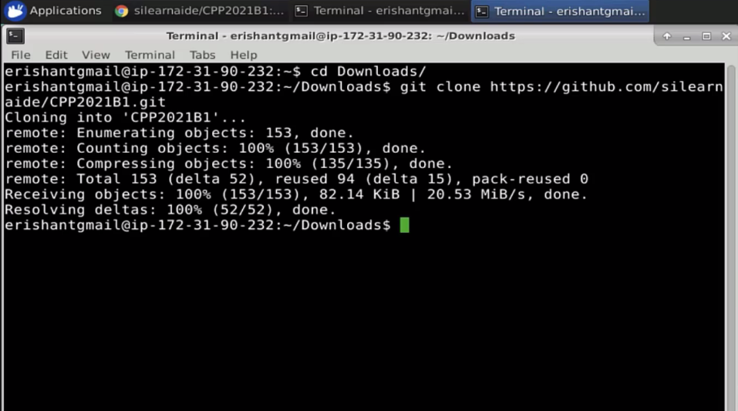

* 1. Now, create a new branch using the git branch command. Go to the cloned repository and create a branch.

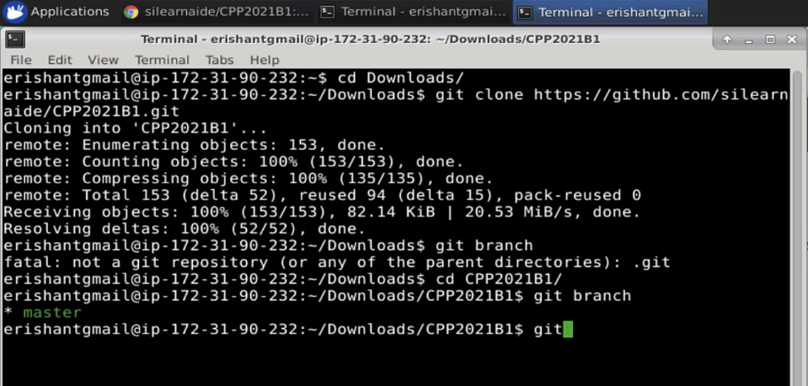

* 1. Type the command **type checkout –b myfeature**

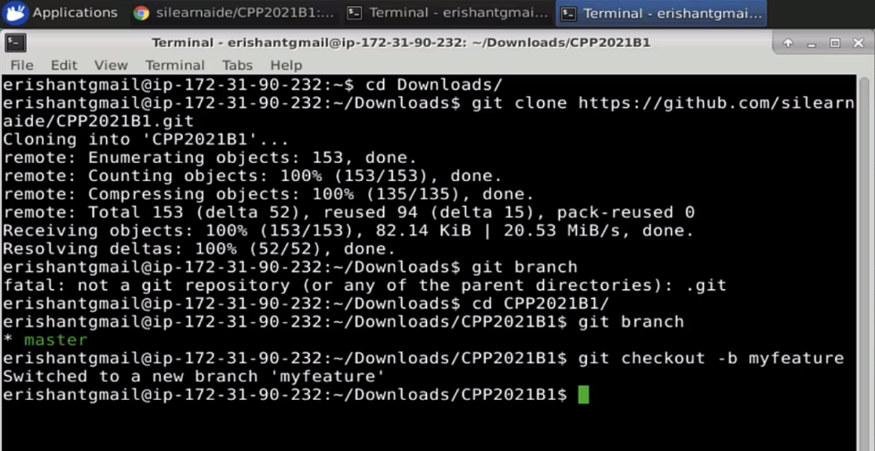

* 1. Now, check if myfeature is created and you will be in the myfeature branch

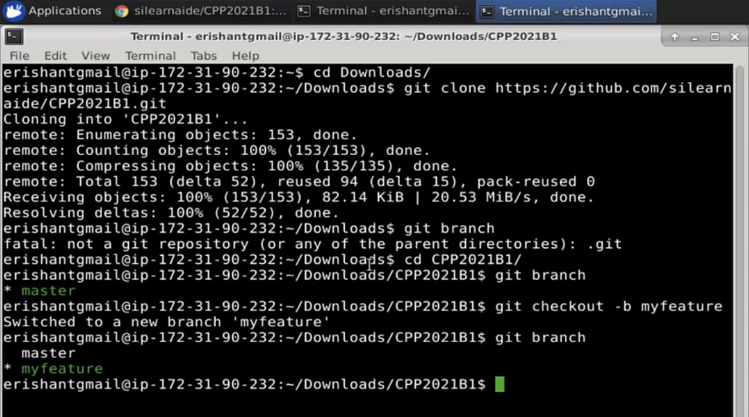

* 1. Now, add a new file to this branch using the **touch** command

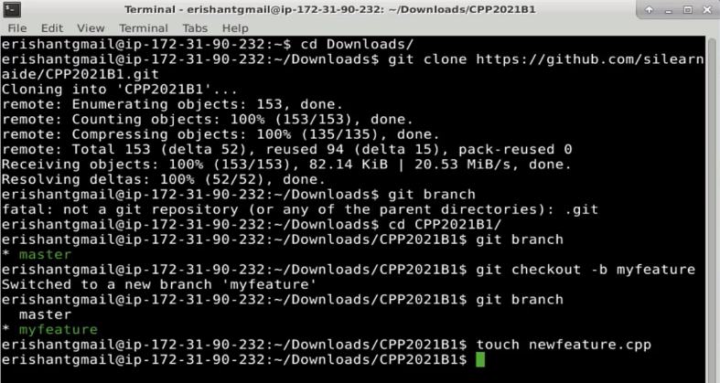

* 1. Check the Git status and add the file to the branch

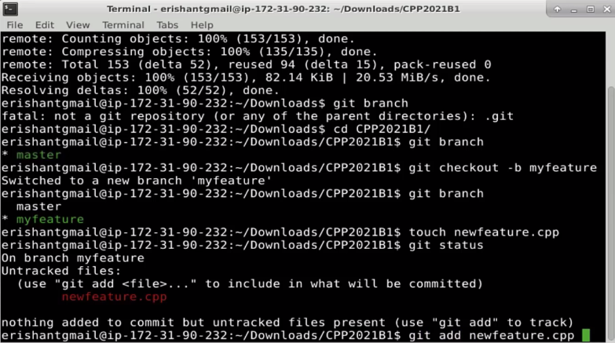

* 1. Now, commit the changes using the **git commit** command with a message

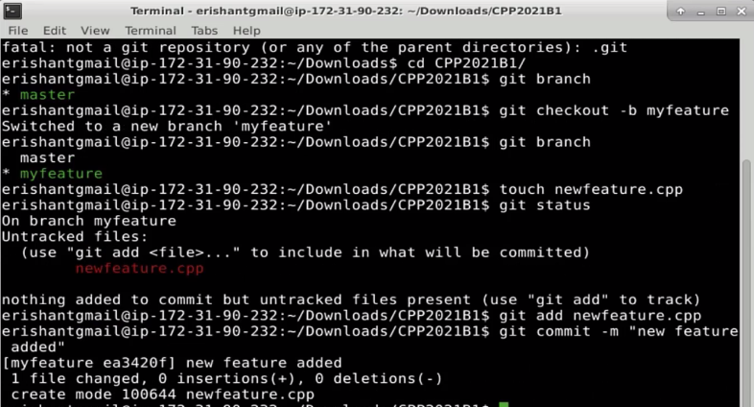

* 1. Now, push this newly committed code to the origin

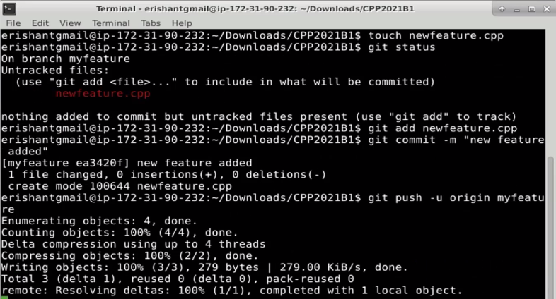

Once this push request is made, a pull request will be created in the origin repository, which must be accepted or rejected by the admin of the origin repository. This describes how to generate a pull request and how to use it.